Etat de l’art

V2X, Vehicle to Everything, refers to a vehicular communication system that will allow vehicles to exchange information with each other, with infrastructures and with pedestrians. Artificial Intelligence mixed with V2X allows to acquire information, expand the driver’s perception, make predictions to avoid accidents, enhance the comfort, the safety and the efficiency of the driving.

V2X : sharing informations from vehicules to everything, promote safety and efficiency of transportation systems by sharing information among vehicles, pedestrians and infras- tructures

2 potential communication technologies that enable V2X:

- Dedicated Short Range Communication (DSRC) based on IEEE 802.11. DSRC enables VANET (no need infrastructures, msg: "Common Awareness Messages" (CAM) and "Basic Safety Messages" (BSM), less than 100 ms)

- Long-Term Evolution (LTE) also called C-V2X (highly reliable, highter bandwidth)

Swarm intelligence

- PSO (particle swarm optimization) -> global optimization algorithm

- ANT (Ant colony optimization) : AntNet (communication routing)

- Swarmcasting (distributed content dowloading to provide audio, resolution videos and peer to peer data streams)

Machine Learning : classification algorithms for Augmented Reality Head Up Display (AR-HUD), active driver information systems, obstacle detection, and predicting com- plex traffic types.

AI for V2X applications:

- DeepRSI: improve driving safety analysis and road safety analysis. deep learning framework to conduct real-time predictions of road safety. These predictions are made based on data obtained from vehicle GPS trajectories and the mobile sensing data collected by the VANETs. (Z.Peng,S.Gao,Z.Li,B.Xiao,andY.Qian,‘‘Vehiclesafetyimprovement through deep learning and mobile sensing,’’ *IEEE Netw.*, vol. 32, no. 4, pp. 28–33, Jul./Aug. 2018. )

Vehicle safety analysis : obtain information of vehicles and road to prevent potential accidents. Information is shared by VANET.

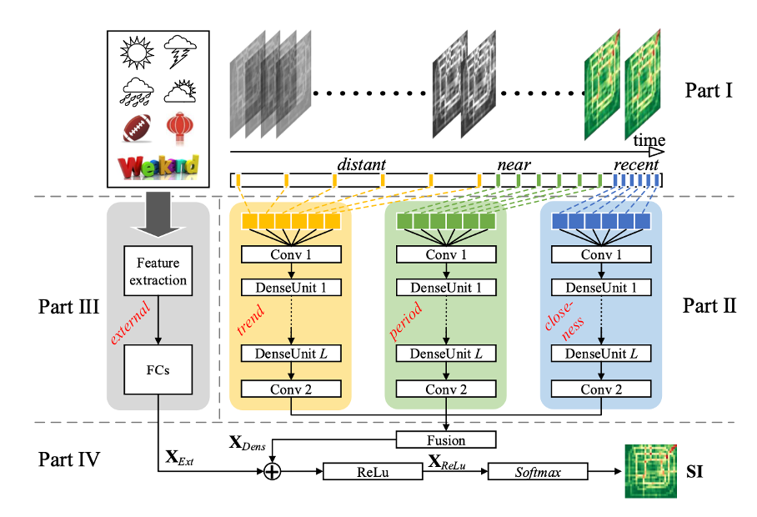

1) Multiple cross-domain data collection

Collect and preprocess datas : urban map, weather data, holiday event data, GPS trajectories generated by over 13,000 taxis, and accident event records. These taxis in VANET are equipped with GPS which can be viewed as a large number of mobile sensors measuring the traveling speed on the road. the city into disjointed grids. Each grid has a unique road safety index to be inferred. Vehicle GPS trajectories are preprocessed and derived into traffic flow in each grid and each time slot in the form of a matrix.

2) Deep spatio-temporal dense network structure

analyze the spatio-temporal pattern of vehicle traffic flow in each region of a city .

Collectively models the spatial and temporal dependencies of vehicle traffic flows between any two regions of a city. Temporal dependencies: division of the temporal axis into three segments: recent time, near time and distant history. The vehicle flow matrices of the time intervals in each segment are then fed into three corresponding temporal components to model three temporal properties: proximity, period, and trend, respectively.

For the spatial dependencies, we design a sequence of dense convolutional units in each time component to model the spatial properties of vehicle traffic.

Thus, three spatio-temporal components are generated, which have a uniform network structure consisting of 2 convolutional layers and L dense convolutional units.

This proposed new deep spatio-temporal dense network structure can collectively capture the spatial and temporal dependencies of vehicle flows between near and far regions of a city.

Consideration of external elements (weather, vacations...)

Goal communicate to the public how safe is an area

- AR-HUD: DL to improve vehicle safety and comfort by performing human factors assessment and displaying the surrounding information to the drivers (to prevent road-side accidents). A form of a dialog between the driver and vehicle. The car provides the driver the surrounding information. It is a real-time deep learning service providing object detection, identification and recognition of road obstacles in complex traffic situations. It is a convolutional neural network that predicts the region of interest and class probabilities from the single image frame. This information processed by one vehicle can be communicated to the other cars through V2X. (A. Lofti and M. Aref, ‘‘Driver information system: A combination of augmented reality, deep learning and vehicular ad-hoc networks,’’ *Int. J. Multimedia Tools Appl.*, vol. 77, no. 12, pp. 14673–14703, Jun. 2018. )

Assets of this algo : precision and short processing time. Detection of all the objects of one image by dividing it in a 7x7 grid.

Algorithms :

- Object detection using Deep Neural Networks

- Divides the images into a regular grid

- Object categories present in the image

- Object classe detection

VANET (Vehicular Ad-Hoc Network) : Ad-Hoc mobile network to provide communications within a group of vehicles within range of each other and between vehicles.

**Vehicle Safety Improvement through Deep Learning and Mobile Sensing:**

* Mobile sensing data collection
* Road safety analysis:
  + - Mathematical model
    - Image analysis
* Driving safety analysis:
  + - Analyzing driving behavior
    - Detecting vehicle’s surroundings
* New deep learning framework (DeepRSI) to conduct real-time road safety index prediction from the data mining point of view:
  + - Two performance metrics: precision and recall.
    - DeepRSI outperforms other methods(SVM, KNN, ANN, DT) in terms of mean precision. and recall

Reinforcement learning :

Markov Decision Processes (MDP) is a discrete-time stochastic control process [37] that provides a mathematical framework for modeling decision making problems. RL is formally defined as an MDP, which consists of:

• S denotes a set of states plus a distribution of starting states p(s0);

• A denotes a set of actions;

• transition dynamics T(st+1|st , at) that map a state-action pair at time t onto a distribution of states at time t + 1;

• an immediate/instantaneous reward function R(st , at , st+1)

• a discount factor γ ∈ [0, 1], where lower values place greater importance on immediate rewards

AI pour les protocoles de communications

1) A decentralized algorithm based on deep reinforcement learning and Markov decision process.

Goal: Improve road safety, traffic efficiency and entertainment experiences on vehicles

To alleviate the impacts of unreliable V2V link

Each V2V pair selects either the V2V mode or the V2I mode based on realistic link qualities (example on the photo)

We model the formulated problem as a Markov decision process (MDP) and propose a DRL-based decentralized algorithm, each V2V pair function as a Deep Reinforcement learning (DRL) agent 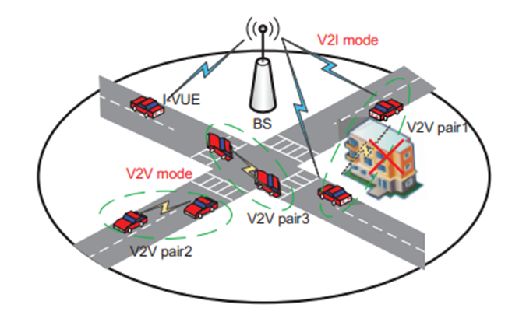

2) Machine Learning to Improve Multi-hop Searching and Extended Wireless Reachability in V2X

Two step machine learning process to improve multi-hop relay and extend wireless reachability

- Segmentation of satellite images

- Assignement of reward and penalty on the map (buildings,open fields,etc)

To recognize obstructions, a DL network is trained to segment three types of classes (i.e., buildings, open ﬁelds,and streets) from aerial images (INRIA dataset)

Labelling each pixel c={buildings, open ﬁelds, streets}

Buildings: include residential areas, and any ﬁeld where thesignal might be blocked by man-made structures.

Open ﬁelds: include parks, and any open area where thesignal might be blocked by sparse vegetation.

Streets: include highways, or wherever a line of sightbetween the transmitter and receiver can be guaranteed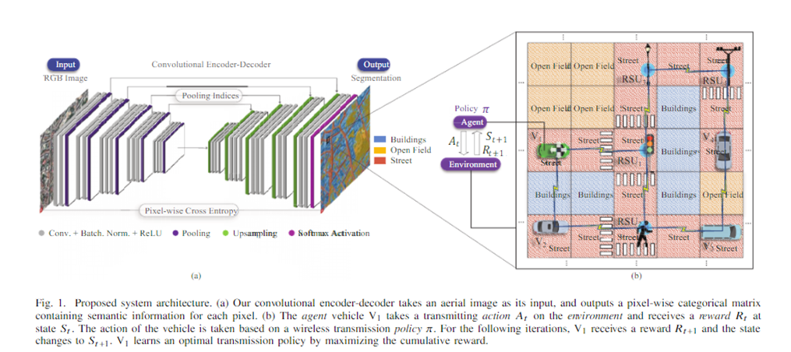

**Deep Predictive Models for Collision Risk Assessment in Autonomous Driving:**

* Investigating a predictive approach for collision risk assessment in autonomous and assisted driving. A deep predictive model is trained to anticipate imminent accidents from traditional video streams. In particular, the model learns to identify cues in RGB images that are predictive of hazardous upcoming situations. In contrast to previous work, our approach incorporates temporal information during decision making, multi-modal information about the environment, as well as the proprioceptive state and steering actions of the controlled vehicle, and information about the uncertainty inherent to the task.
* The core of the used model is a deep network containing a combination of convolutional and recurrent layers that process the input image sensor data in both space and time. This novel deep network architecture will be referred to as Bayesian ConvLSTM and will be explained in more detail below. An important feature in this regard is the ability of the DPM to work with multimodal data representing different types of available information.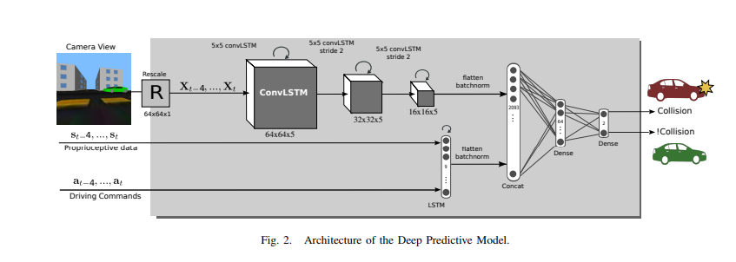

**Sitographie:**

**​​-** [**https://www.qualcomm.com/media/documents/files/ihs-technology-whitepaper-cellular-vehicle-to-everything-c-v2x-connectivity.pdf**](https://www.qualcomm.com/media/documents/files/ihs-technology-whitepaper-cellular-vehicle-to-everything-c-v2x-connectivity.pdf)

**-** [**https://moodle.insa-rouen.fr/pluginfile.php/167510/mod_folder/content/0/Rapport_P6_2021_03.pdf**](https://moodle.insa-rouen.fr/pluginfile.php/167510/mod_folder/content/0/Rapport_P6_2021_03.pdf)

**-** [**https://ieeexplore.ieee.org/stamp/stamp.jsp?tp=&arnumber=8605302**](https://ieeexplore.ieee.org/stamp/stamp.jsp?tp=&arnumber=8605302)

**-** [**https://www.youtube.com/watch?v=mhzkSoAgvXA**](https://www.youtube.com/watch?v=mhzkSoAgvXA)

**-** [**https://ieeexplore.ieee.org/stamp/stamp.jsp?tp=&arnumber=9040539**](https://ieeexplore.ieee.org/stamp/stamp.jsp?tp=&arnumber=9040539)

**-** [**https://www.researchgate.net/publication/318892220_Driver_information_system_a_combination_of_augmented_reality_deep_learning_and_vehicular_Ad-hoc_networks**](https://www.researchgate.net/publication/318892220_Driver_information_system_a_combination_of_augmented_reality_deep_learning_and_vehicular_Ad-hoc_networks)

**-** [**http://dsp.tecnalia.com/bitstream/handle/11556/637/a%20linear%20model_.pdf;jsessionid=6C5E5B19EB71238C253CEA0742679D1A?sequence=1**](http://dsp.tecnalia.com/bitstream/handle/11556/637/a%20linear%20model_.pdf;jsessionid=6C5E5B19EB71238C253CEA0742679D1A?sequence=1)

**-** [**https://interactive-robotics.engineering.asu.edu/wp-content/uploads/2018/03/icra_2018_1.pdf**](https://interactive-robotics.engineering.asu.edu/wp-content/uploads/2018/03/icra_2018_1.pdf)